Batch: B2 Roll No.: 16010121200
Experiment No: 6
Grade: AA / AB / BB / BC / CC / CD /DD

Signature of the Staff In-charge with date

Title: Back propagation algorithm
____________________________________________________________________________________
Objective: To Write a program to implement back propagation algorithm in MLP.
____________________________________________________________________________________
Expected Outcome of Experiment:
CO3: Understand perceptron’s and counter propagation networks
____________________________________________________________________________________
Books/ Journals/ Websites referred:

____________________________________________________________________________________
Pre Lab/ Prior Concepts:
____________________________________________________________________________________

Back-propagation training algorithm:
Forward Pass:
- Inputs are given through the distribution layer
- Net input is calculated for each neuron in the hidden layer
- Activation function is applied on the net to obtain output from the hidden layer
- Output of the hidden layer is used to calculate net input for the output layer.
- Activation function is applied on the net to obtain output from the output layer.
Reverse Pass:
- Calculate the error by subtracting calculated output from desired output. (t-y)
- Calculate error signal for all the layers.
- Back propagate the error to the previous layer through the weights.
- Update weights accordingly.
Network Architecture:
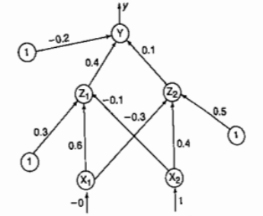
Solved example: (taken from Sivanandam book)
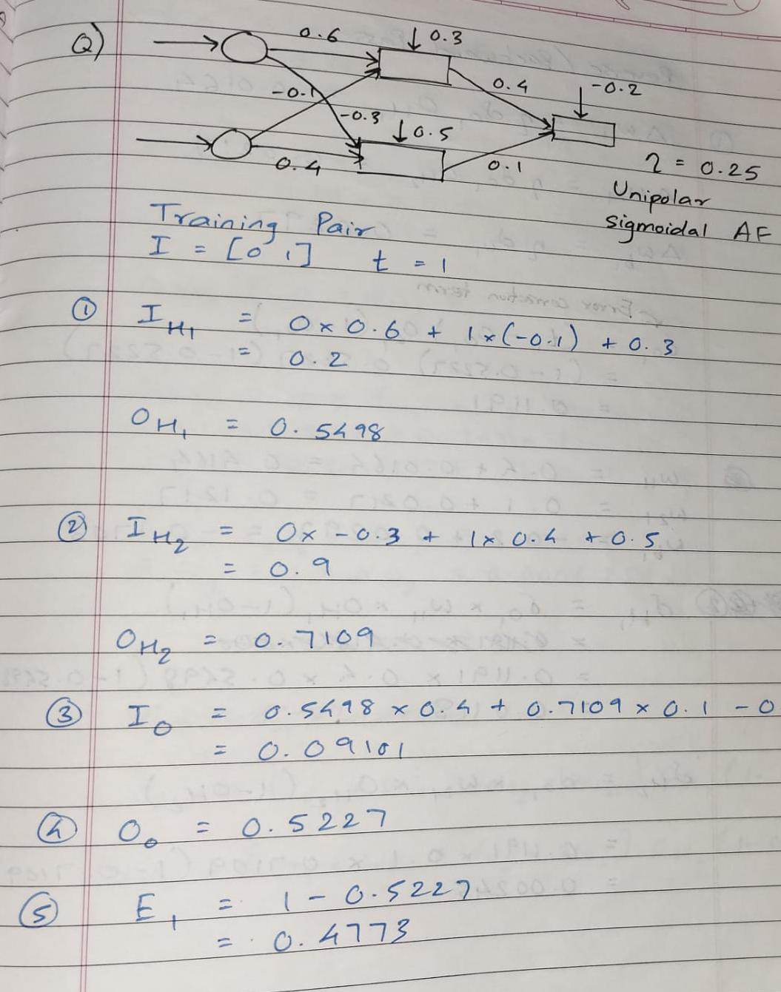
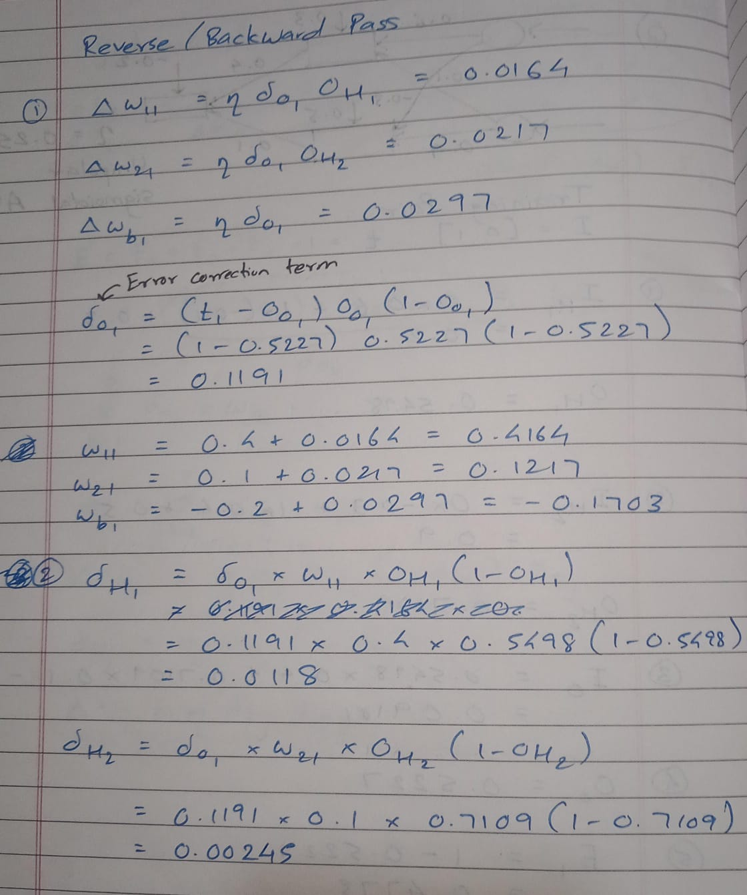
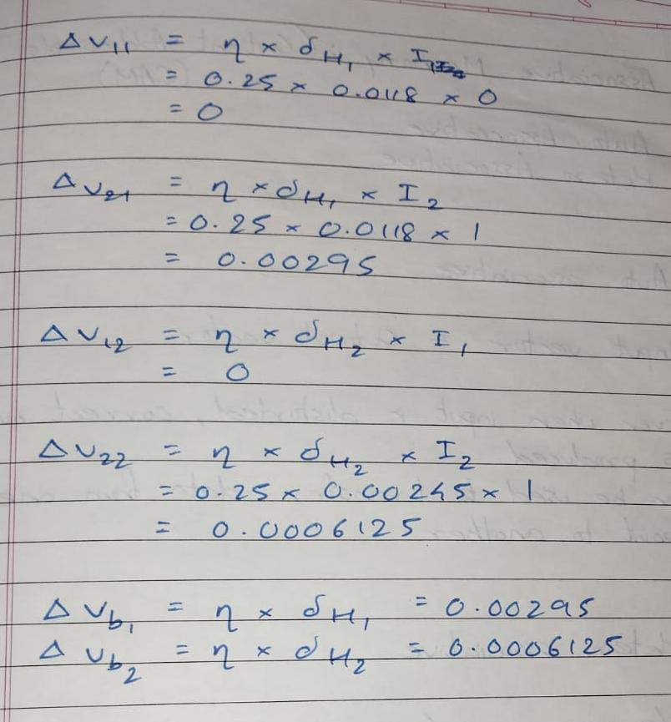
Flowchart:
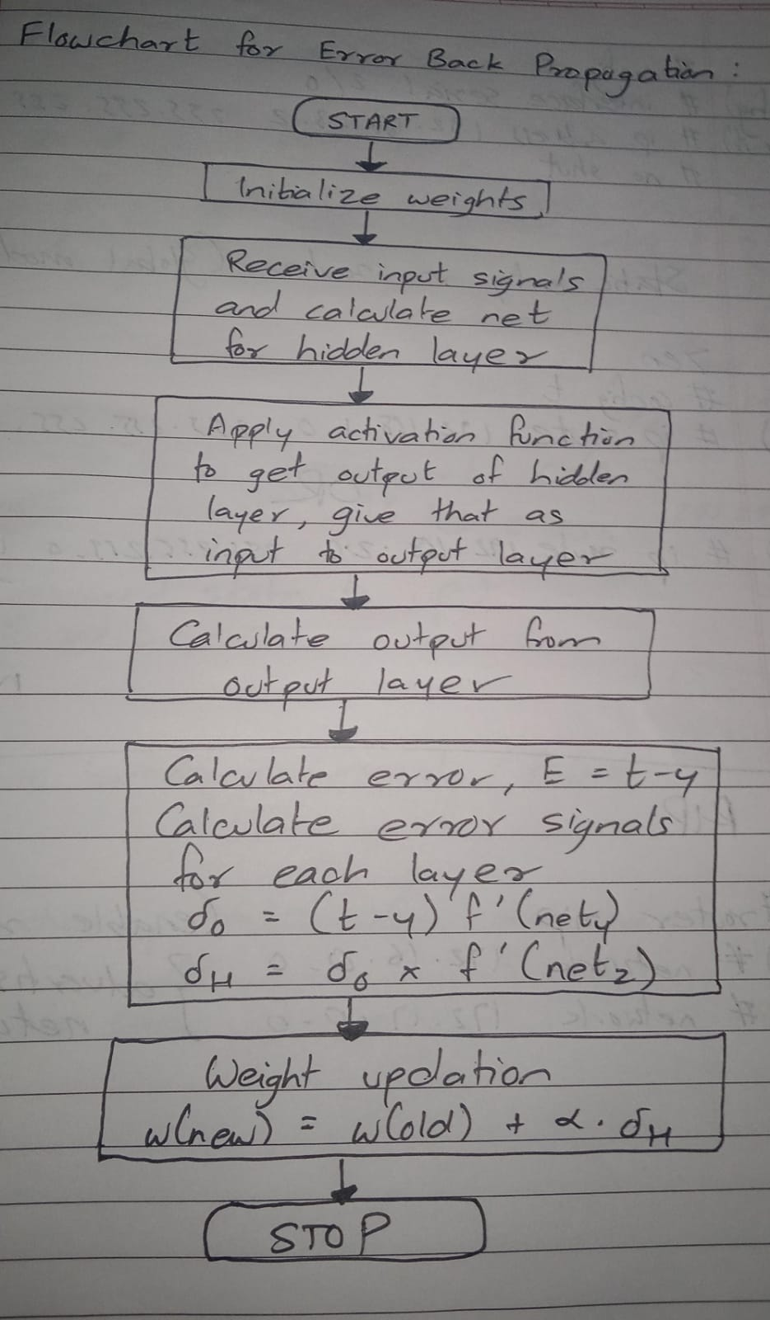

Implementation Details:

To implement EBPT algorithm to find the new weights for the network given for given input output pair for certain no. of epochs.
Program:
import math

# Activation function
def activation(net):
return 1 / (1 + math.exp(-1*net))

def calc_net(inputs, weights):
"""Calculates the net input for a neuron"""
x1, x2 = inputs
w1, w2, w0 = weights
net = x1*w1 + x2*w2 + w0
return net

def neuron(net):
"""Applies the activation function to calculate the output"""
output = activation(net)
return output

def errorBackPropogation(input_, target):
# Initialization
lr = 0.25
v11 = 0.6
v21 = -0.1
v01 = 0.3
v12 = -0.3
v22 = 0.4
v02 = 0.5
w1 = 0.4
w2 = 0.1
w0 = -0.2
print("Learning rate =", lr)
initial_weights = [v11, v21, v01, v12, v22, v02, w1, w2, w0]
table1 = [["v11"], ["v21"], ["v01"],
["v12"], ["v22"], ["v02"],
["w1"], ["w2"], ["w0"]]
i = 0
for row in table1:
row.append(initial_weights[i])
i +=1

# Forward pass
print("\nForward Pass")
x1, x2 = input_
table2 = []
# Neuron Z1
weight = [v11, v21, v01]
z_in1 = calc_net(input_, weight)
z1 = neuron(z_in1)
table2.append(["Z1", z_in1, z1])
# Neuron Z2
weight = [v12, v22, v02]
z_in2 = calc_net(input_, weight)
z2 = neuron(z_in2)
table2.append(["Z2", z_in2, z2])
# Neuron Y
weight = [w1, w2, w0]
input_ = (z1, z2)
y_in = calc_net(input_, weight)
y = neuron(y_in)
table2.append(["Y", y_in, y])
printForwardTable(table2)
# Reverse pass
# Calculate error and error signals
error = target - y
dy = error * y * (1 - y)
dz1 = dy * w1 * z1 * (1 - z1)
dz2 = dy * w2 * z2 * (1 - z2)
print("\nError Calculations")
print("-----------------------------------------------------------------")
print("Error\t\t| d1\t\t| d_in1\t\t| d_in2\t\t|")
print("-----------------------------------------------------------------")
print("%5.4f\t\t| %5.4f\t| %5.4f\t| %5.4f\t|" % (error, dy, dz1, dz2))
print("-----------------------------------------------------------------")
# Adjust weights
w0 += lr * dy
w1 += lr * dy * z1
w2 += lr * dy * z2
v01 += lr * dy
v11 += lr * dz1 * x1
v21 += lr * dz1 * x2
v02 += lr * dz2
v12 += lr * dz2 * x1
v22 += lr * dz2 * x2
updated_weights = [v11, v21, v01, v12, v22, v02, w1, w2, w0]
i = 0
for row in table1:
row.append(updated_weights[i])
i +=1
print("\nWeight Adjustments")
printWeightAdjustments(table1)
return

def printForwardTable(table):
print("------------------------------------------------------------------")
print("Neuron\t\t | net\t\t\t | output\t\t |")
print("------------------------------------------------------------------")
for row in table:
print(row[0], end = "\t\t | ")
for value in row[1:]:
print("%5.4f" % value, end = "\t\t | ")
print()
print("------------------------------------------------------------------")
return

def printWeightAdjustments(table):
""" Prints the weight updation table"""
print("------------------------------------------------------------------")
print("Weight\t\t | Initial value\t | Updated value\t |")
print("------------------------------------------------------------------")
for row in table:
print(row[0], end = "\t\t | ")
print("%5.1f\t\t | %5.4f\t\t |" % (row[1], row[2]))
print("------------------------------------------------------------------")
return

input_value = (0,1) # Input
target = 1 # Desired output
errorBackPropogation(input_value, target) # Passing the input and output parameters to the network

Output:
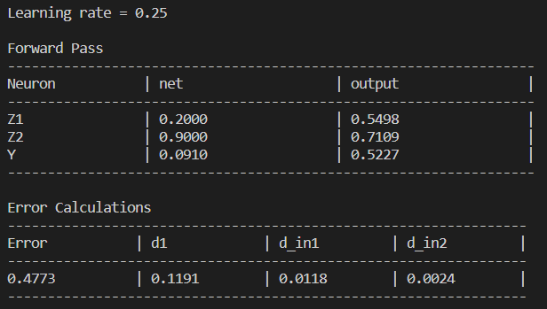
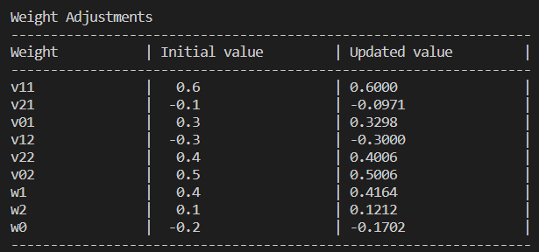
Conclusion:
Successfully implemented error back propagation algorithm.

Post Lab Descriptive Questions:

- What is meant by local and global minima?
A local minimum of a function is a point where the function value is smaller than at nearby points, but possibly greater than at a distant point.
A global minimum is a point where the function value is smaller than at all other feasible points.
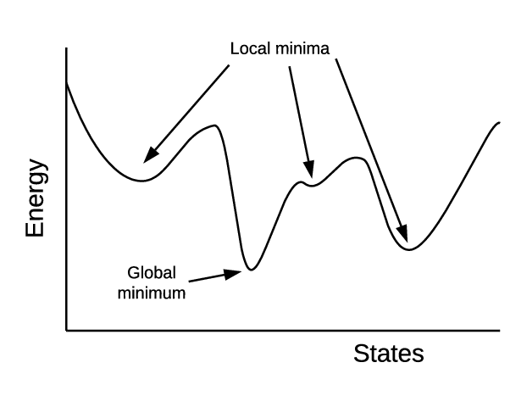
- What are factors that can improve the convergence of learning in back propagation learning algorithm?
The following factors can improve the convergence of learning in the back propagation algorithm:
- Initial weights
- Steepness of activation function
- Learning constant
- Momentum factor
- Network architecture
- Number of hidden neurons

